Dresses donated by Rita Ora hang among 5,000 outfits pegged to washing lines for a powerful art exhibition in her home country of Kosovo condemning rape of women during the Balkan War
- Thousands of dresses and skirts have been pinned across a football stadium in Pristina Stadium for exhibition
- London-based artist Alketa Xhafa-Mripa said she wants to help the women 'blamed and shamed' for being raped
- Atrocities occurred during the Kosovo War of 1998-9 - but women and girls attacked are still being ostracised
By Elaine O'flynn For Mailonline and Reuters
Published: 18:44 GMT, 12 June 2015 | Updated: 19:22 GMT, 12 June 2015
Thousands of dresses and skirts - including ones donated by popstar Rita Ora and Tony Blair's wife Cherie - have been pinned to washing lines in a Kosovo football stadium to highlight the suffering of victims of sexual violence.
The striking art exhibition 'Thinking Of You' looks to address the stigma of the women and girls raped during the Kosovo War between 1998 and 1999, as the country struggles to address the horrors endured by females during the terrifying period.
It is thought thousands of women and girls were sexually assaulted by Serbian forces and paramilitaries, but the exact number is unknown due to the stigma victims feel, almost 20 years on.
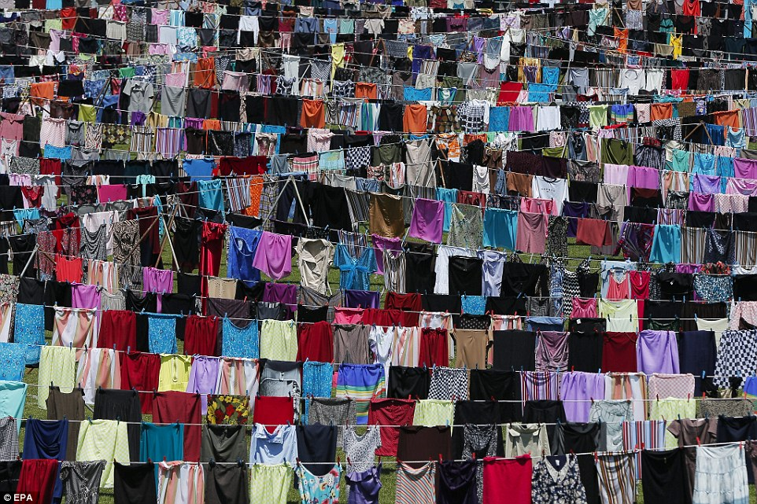
Poignant: The 'Thinking Of You' exhibition seen 5,000 dresses and skirts pinned to washing lines in a Kosovo football stadium
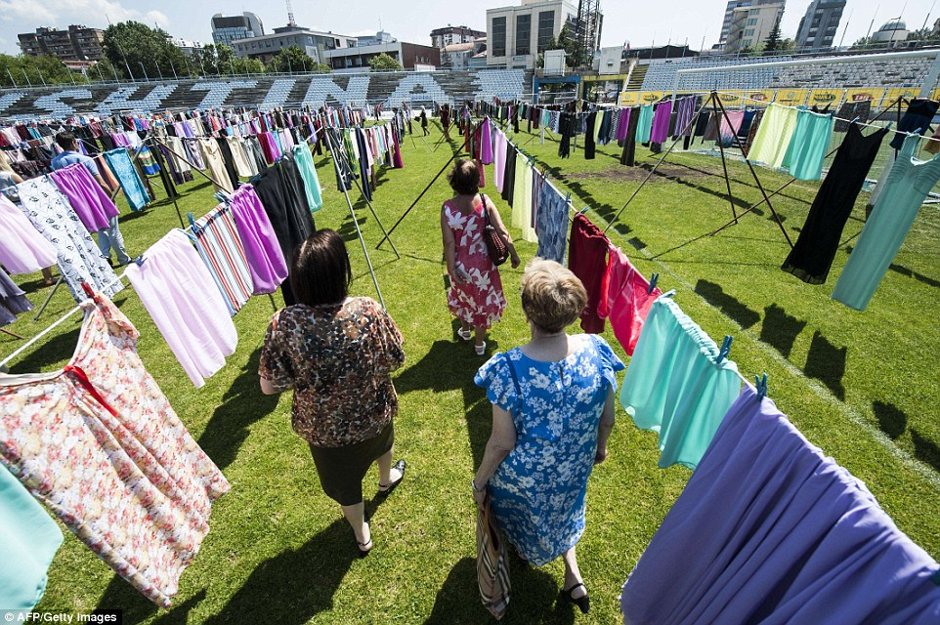
Moving: Kosovo Albanian women walk through the display. Among the dresses donated are ones from Cherie Blair and popstar Rita Ora
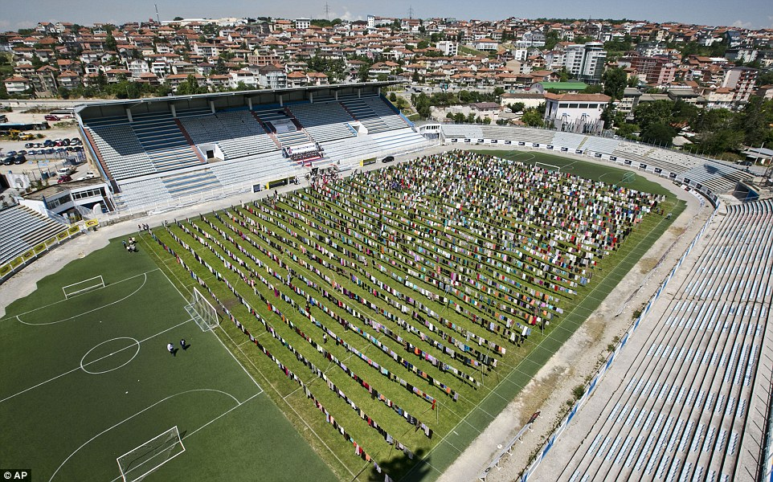
Colour: Rows of clothing that make up the bright exhibition that has taken over an entire football pitch in Pristina Stadium, in eastern Kosovo
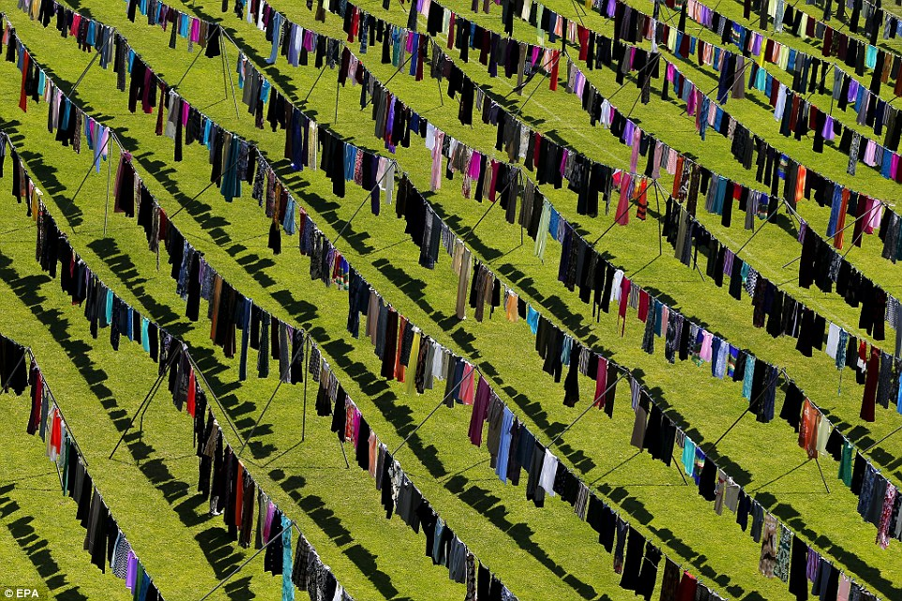
Horror: The exhibition is an attempt to address the stigma still faced by women who were sexually assaulted during the Kosovo War in 1998-9
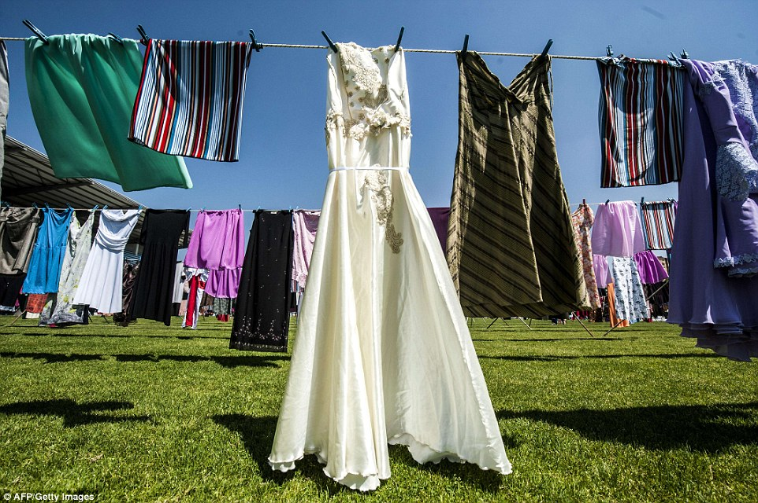
Fear: Many of the women who have spoken out about their ordeals since the war have been ostracized by conservative communities in Kosovo, while others who were raped by Serbian soldiers and paramilitaries were later divorced by their husbands
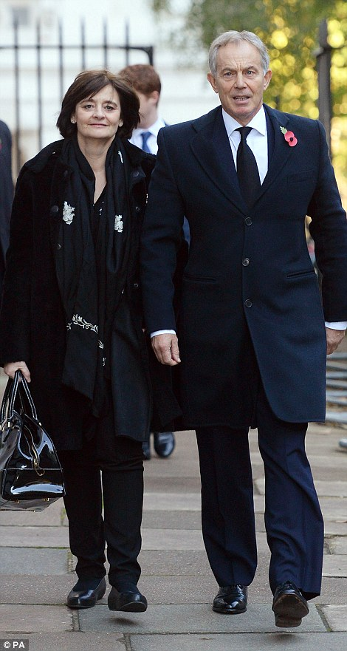
Celebrity support: British popstar Rita Ora (left), born in Kosovo, donated a dress to the exhibition, as did Tony Blair's wife Cherie (right). Mr Blair when NATO intervened to drive out Serbian forces accused of massacring and expelling ethnic Albanian civilians
Some of those who have spoken out have faced criticism and been ostracised by Kosovo's conservative and mainly Muslim Albanian society, while women who had been raped were later divorced by their husbands.
The London based artist Alketa Xhafa-Mripa, who was born in Kosovo, said she felt fortunate to have not been in her homeland during the atrocities, adding the women received 'the blame and the shame'.
'I was lucky to be in London during the war and I always thought this could have happened to me as it happened to these women,' she told Reuters.
The Voice judge and pop star Rita Ora, who was born in Kosovo, donated one of 5,000 dresses pegged to the washing lines in the Pristina Stadium, in eastern Kosovo

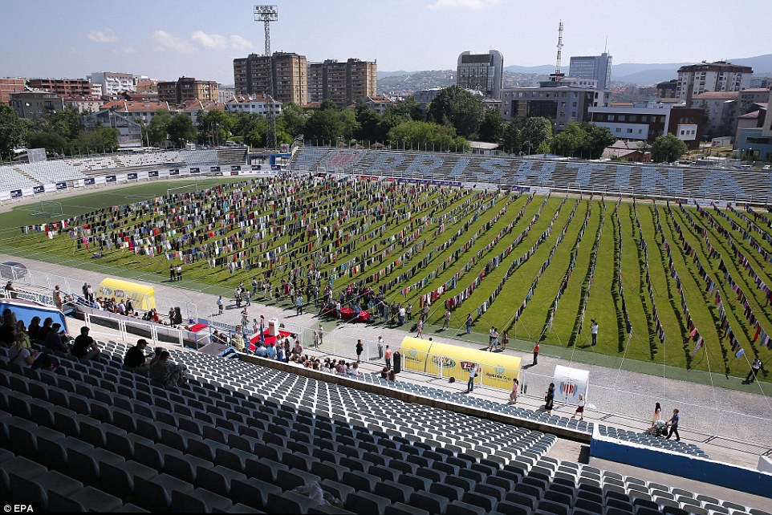
Display: The exhibition of 5,000 dresses and skirts has been put in place in a football stadium in Pristina, in the east of Kosovo
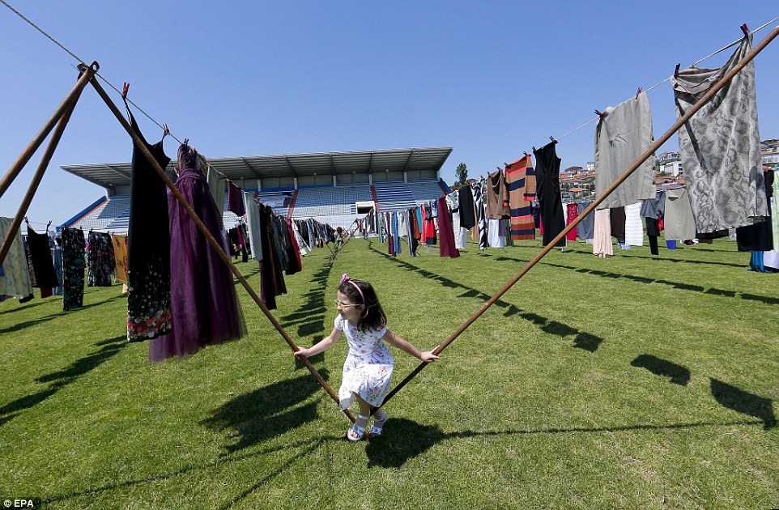
Legacy: A little girl plays in the exhibition. Artist Alketa Xhafa-Mripa said she hopes the exhibition will help those who experienced sexual violence during the conflict speak out about their experiences, without fear of being ostracised by Kosovo's conservative communities
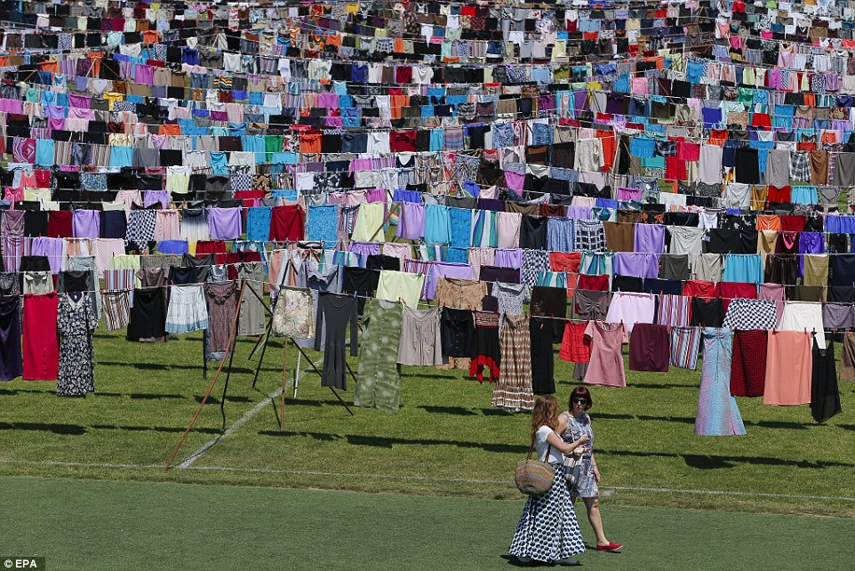
Change: A new law was introduced in Kosovo last year which would mean there is welfare support for victims of rape within the country
Other donations came from Atifete Jahjaga, Kosovo's first female president, and Cherie Blair, whose husband Tony was British prime minister when NATO intervened to drive out Serbian forces accused of massacring and expelling ethnic Albanian civilians.
Kosovo, once a province of Serbia, declared independence in 2008 and has been recognised by more than 100 states worldwide.
On one blue skirt was written: 'This skirt carries a hidden story from spring 1998. Dardani, Peje,' referring to the names of a district and town.
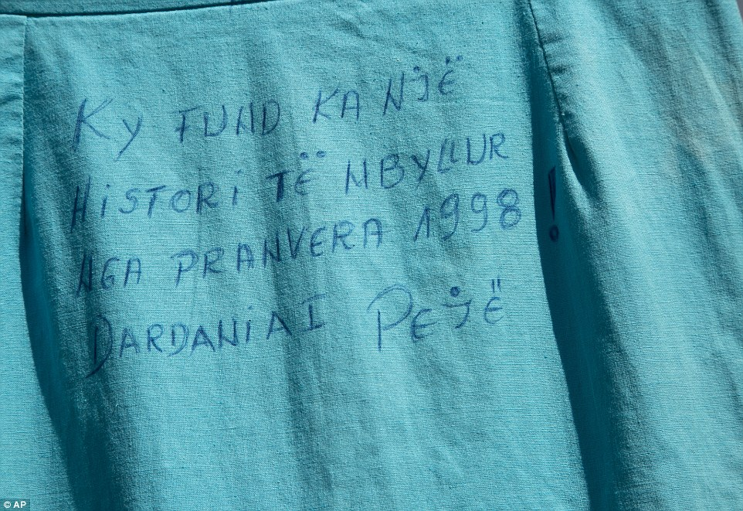
Moving: One of the skirts has been written on. It reads: 'This skirt carries a hidden story from spring 1998. Dardani, Peje', referring to the names of a district and town in Kosovo
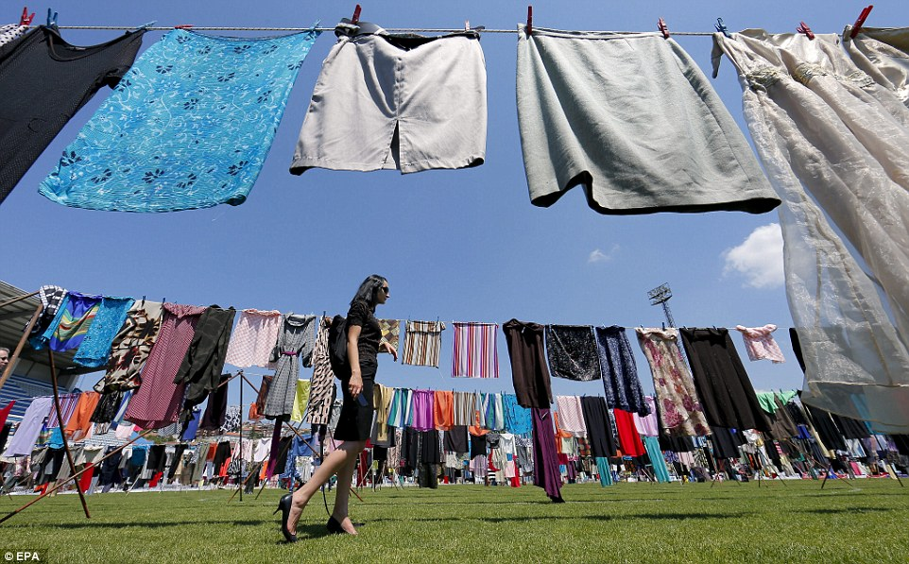
Painful: A non-government organisation official revealed nine women in the area she has worked in committed suicide after being raped
Kadire Tahiraj, who runs a non-governmental organisation helping victims of sexual violence, said nine woman in the Gllogoc area where she works had committed suicide after being raped.
'A lot of raped women were later divorced by their husbands,' Tahiraj said.
'I spoke with a woman who was pregnant when she was raped and lost the baby. Her husband later divorced her.'
Criticised for its failure to act on the issue, lawmakers in Kosovo last year adopted a law to provide welfare support for rape victims, but the government has yet to define how much

